Digital Delivery External API Service
Cyber Suite 2.0
Version 8.0

Table of Contents
1 Overview 3
2 Business Purpose 3
3 Architecture 3
3.1 Service Topology Diagram 4
4 Security 4
5 Digital delivery Quote API 4
5.1 Request Message 4
5.2 Request Validation 10
5.3 Response Message 10
6 digital delivery BIND API 21
6.1 Request Message 21
6.2 Request Validation 26
6.3 Response Message 26
7 Exception Handling and Recovery 33
8 How to Test 35
9 Document Revision History 40

Overview
Hartford Steam Boiler (HSB) is constantly expanding its portfolio of system to system integration options via APIs hosted on Microsoft’s Azure Cloud.

Business Purpose
HSB reinsurance treaties are typically implemented and maintained in full by our clients. The client’s Quote, Issuance, and Policy Admin systems must be programmed to support the HSB products, and adopting changes to those products is the responsibility of the client. Clients may spend more than a year to plan and implement a new HSB product, and eventual changes to the product can present significant IT expense to adopt. This is particularly burdensome when new HSB products are evolving quickly to meet market demands. The purpose of the HSB Digital Delivery platform is to reduce the burden on client companies to deploy and maintain HSB products.
- The Digital Delivery Quote API will respond with the client company’s filed product limits, rates, deductibles, eligibility rules and form numbers.
- The Digital Delivery Bind API will respond with the client company’s filed forms and declaration pages, complete with selected product options.

Architecture
HSB has built a secured cloud Application Program Interface (API) to provide information related to Digital Delivery.
API’s are available through Secure Cloud with various security options, see section 4 for information.

Service Topology Diagram

Security
Access to HSB’s API products begins by obtaining a subscription account, and then enable your API module for that account. An API account can be coordinated through HSB’s integration team:
HSBIntegrationTeam@hsb.com
HSB utilizes Microsoft Azure’s API Management tool for exposing internal APIs to external Client Companies by applying two security/authentications to the HSB API (internal) and access the API from the Internet (external):
Security Level 1: URL and HSB provided Subscription Key,
Security Level 2: URL and HSB provided Subscription Key plus OAuth2 Token/certificate.

Digital Delivery Quote API
This service allows an external system to create Quote.

Request Message

Type | SubType | Field | Required for API | Required for Reporting | Description
SignonRq | SignonTransport/CustId | SPName | Y | Y | Domain name of carrier
SignonRq | SignonTransport/CustId | CustLoginId | Y |  | Identity of carrier - parent company
SignonRq |  | ClientDt | Y |  | Date and time stamp from carrier's system
SignonRq |  | CustLangPref | Y |  | Preferred language of requester
SignonRq | ClientApp | Org | Y |  | Name of requesting company
SignonRq | ClientApp | Name | Y |  | Insurer application name where request is originating from
SignonRq | ClientApp | Version | Y |  | Version of insurer application where request is originating from
InsuranceSvcRq | ItemIdInfo/OtherIdentifier | UID | Y |  | Unique identifier of the request.
InsuranceSvcRq | PolicyRq | BusinessPurposeTypeCd | Y | Y | This field identifies the type of transaction(NBQ,RWQ,PCQ,REW)
InsuranceSvcRq | PolicyRq /ItemIdInfo/OtherIdentifier | UID | Y |  | Unique identifier of the request. It should be returned along with response to correlate.
InsuranceSvcRq | PolicyRq | TransactionRequestDt | Y |  | DateTime that carrier submits request to HSB
InsuranceSvcRq | PolicyRq | TransactionEffectiveDt |  | Y | DateTime on which transaction takes effect  Mandatory in case of PCH transaction
InsuranceSvcRq | PolicyRq | ACORDStandardVersionCd | Y |  | ACORD Version Number. APIs are operating at 280 version and will support lower versions as well.
InsuranceSvcRq | PolicyRq /Producer/ItemIdInfo | InsurerID |  |  | The agent ID an Insurer assigned to an individual Agent
InsuranceSvcRq | PolicyRq /Producer | ContractNumber |  |  | Optional field for the agency/broker number or code assigned by the insurer
InsuranceSvcRq | PolicyRq /Producer | PlacingOffice |  |  | Optional field for identifying the branch Id or code for the agency assigned by the insurer
InsuranceSvcRq | PolicyRq /InsuredOrPrincipal | Name |  | Y | Name of Insured Company or Person
InsuranceSvcRq | PolicyRq /InsuredOrPrincipal /SupplementaryNameInfo | SupplementaryNameCd |  |  | Code indicating type of supplementary name(DBA)
InsuranceSvcRq | PolicyRq /InsuredOrPrincipal /SupplementaryNameInfo | SupplementaryName |  |  | Supplementary name for the Insured
InsuranceSvcRq | PolicyRq /InsuredOrPrincipal/Addr | Addr1 |  | Y | Mailing address of the Insured
InsuranceSvcRq | PolicyRq /InsuredOrPrincipal/Addr | City |  | Y | Mailing City of the insured
InsuranceSvcRq | PolicyRq /InsuredOrPrincipal/Addr | StateProvCd |  | Y | Mailing State of the insured
InsuranceSvcRq | PolicyRq /InsuredOrPrincipal/Addr | PostalCode |  | Y | Mailing postal code of insured
InsuranceSvcRq | PolicyRq /InsuredOrPrincipal | SICCd | Can be optional/Mandatory Can be configured based on carrier preference |  | SIC Industry Code related to Insured
InsuranceSvcRq | PolicyRq /InsuredOrPrincipal | NAICSCd |  |  | NAICS industry code related to the insured
InsuranceSvcRq | PolicyRq /InsuredOrPrincipal | GeneralLiabilityCd |  |  | General Liability code related to the insured
InsuranceSvcRq | PolicyRq /Policy | Policy Number | Y | Y | Policy number will be optional for New business and rewrite transaction and it will be mandatory for policy change and renewal transaction.
InsuranceSvcRq | PolicyRq /Policy | LOBCd | Y | Y | Clients policy that we are attaching to(CGL,BOP and PROP)  Commercial package Policy has code of PROP in ACORD.
InsuranceSvcRq | PolicyRq/Policy | NAICCd | Y |  | NAIC code of the writing company
InsuranceSvcRq | PolicyRq/Policy | ControllingStateProvCd | Y |  | Controlling state of the underlying policy to which HSB products may be attached.
InsuranceSvcRq | PolicyRq /Policy/ContractTerm | EffectiveDt | Y | Y | Effective date of underlying policy to which HSB products will be attached
InsuranceSvcRq | PolicyRq /Policy/ContractTerm | ExpirationDt | Y | Y | Expiration date of underlying policy to which HSB products will be attached
InsuranceSvcRq | PolicyRq /Policy/OtherOrPriorPolicy | PolicyCd |  |  | Code used to identify the type of policy being defined. In this case it is ‘Prior’
InsuranceSvcRq | PolicyRq /Policy/OtherOrPriorPolicy | PolicyNumber |  | Y | Prior Policy Number for Rewrite transactions
InsuranceSvcRq | PolicyRq /Policy/QuoteInfo | CompanysQuoteNumber |  |  | Carrier's quote number
InsuranceSvcRq | PolicyRq /Policy | RenewalStatusCd |  |  | RenewalStatusCd is to identify the policy type for PCQ transaction whether NBS or RWL.  For new business will be blank, for renewal value equal to “Renewed”
InsuranceSvcRq | PolicyRq /Policy/Coverage | CoverageCd |  | Y | Code for the coverage provided (CLIAB)  Coverage is an optional node; This node is used to identify the current coverage on an in-force policy, therefore would not apply if no current coverage exists; optional field for the transactions - NBQ,RWQ and PCQ unless there is existing coverage.  Required for Rewrite -REW
InsuranceSvcRq | PolicyRq /Policy/Coverage/Limit | FormatInteger |  |  | Current limit Amount, optional for New Business
InsuranceSvcRq | PolicyRq /Policy/Coverage/Limit | LimitAppliesToCd |  |  | Current limit amount code, optional for Business types(Aggregate)
InsuranceSvcRq | PolicyRq /Policy/Coverage | EffectiveDt |  | Y | Effective date of underlying policy to which HSB products will be attached.  Effective date will be mandatory in only PCQ transaction.
InsuranceSvcRq | PolicyRq /Policy/Coverage/CoverageSupplement/ClaimsMadeInfo | UninterruptedClmMadeCovEntryDt |  |  | Original inception date of when the coverage was first added
InsuranceSvcRq | PolicyRq /Policy/PolicyExt | ApprovalNumber |  |  | Provided by HSB during referral workflow-  Format : ANCS000001
InsuranceSvcRq | PolicyRq /Location | id | Y |  | Location Identifier  (Need to check about Accord standard)
InsuranceSvcRq | PolicyRq /Location/Addr | Addr1 |  |  | Location Address
InsuranceSvcRq | PolicyRq /Location/Addr | City |  |  | Location City
InsuranceSvcRq | PolicyRq /Location/Addr | StateProvCd |  |  | Location State
InsuranceSvcRq | PolicyRq /Location/Addr | PostalCode |  |  | Location Postal Code
InsuranceSvcRq | PolicyRq /Location | LocationName |  |  | Descriptive name of the locaiton
InsuranceSvcRq | PolicyRq /GeneralLiabilityLineBusiness/ LiabilityInfo/ GeneralLiabilityClassification | LocationRef | Y |  | Connects class of business codes to the appropriate location
InsuranceSvcRq | PolicyRq /GeneralLiabilityLineBusiness/ LiabilityInfo/ GeneralLiabilityClassification | ClassCd | Y | Y | Location level class of business  ClassCd will not be mandatory when approval number is given.
InsuranceSvcRq | PolicyRq /GeneralLiabilityLineBusiness/ LiabilityInfo/ GeneralLiabilityClassification | ClassCdDesc |  | Y | Class Code Description
InsuranceSvcRq | PolicyRq/ BOPLineBusiness/ PropertyInfo/ CommlPropertyInfo | LocationRef | Y |  | Connects class of business codes to the appropriate location
InsuranceSvcRq | PolicyRq/ BOPLineBusiness/ PropertyInfo/ CommlPropertyInfo | ClassCd | Y | Y | Location level class of business  ClassCd will not be mandatory when approval number is given.
InsuranceSvcRq | PolicyRq/ BOPLineBusiness/ PropertyInfo/ CommlPropertyInfo | ClassCdDesc |  | Y | Class Code Description
InsuranceSvcRq | PolicyRq/ BOPLineBusiness/ LiabilityInfo/ GeneralLiabilityClassification | LocationRef | Y |  | Connects class of business codes to the appropriate location
InsuranceSvcRq | PolicyRq/ BOPLineBusiness/ LiabilityInfo/ GeneralLiabilityClassification | ClassCd | Y | Y | Location level class of business  ClassCd will not be mandatory when approval number is given.
InsuranceSvcRq | PolicyRq/ BOPLineBusiness/ LiabilityInfo/ GeneralLiabilityClassification | ClassCdDesc |  | Y | Class Code Description
InsuranceSvcRq | PolicyRq/ CommlPropertyLineBusiness/ PropertyInfo/ CommlPropertyInfo | LocationRef | Y |  | Connects class of business codes to the appropriate location
InsuranceSvcRq | PolicyRq/ CommlPropertyLineBusiness/ PropertyInfo/ CommlPropertyInfo | ClassCd | Y | Y | Location level class of business  ClassCd will not be mandatory when approval number is given.
InsuranceSvcRq | PolicyRq/ CommlPropertyLineBusiness/ PropertyInfo/ CommlPropertyInfo | ClassCdDesc |  | Y | Class Code Description

Request Validation
Requests that do not contain elements marked as “Y” will generate a failure response from the API. See Section 7 for details regarding Exception Handling and Recovery.

Response Message
Type | Sub Type | Field | Description
SignonRs | Status | StatusCd | Status of transaction
SignonRs | Status | StatusDesc | Description of transaction status
SignonRs | CustId | SPName | Domain name of carrier
SignonRs | CustId | CustLoginId | Identity of carrier - parent company
SignonRs |  | ClientDt | Date and time stamp from carrier's system
SignonRs |  | CustLangPref | Preferred language of requester
SignonRs | ClientApp | Org | Name of requesting company
SignonRs | ClientApp | Name | Application being requested
SignonRs | ClientApp | Version | Application Version
SignonRs |  | ServerDt | Date and time stamp from HSB's system
SignonRs |  | Language | Language of the HSB response
InsuranceSvcRs | ItemIdInfo/ OtherIdentifier | UID | Unique identifier of the request or response.
InsuranceSvcRs | PolicyRs | BusinessPurposeTypeCd | This field identifies the type of transaction
InsuranceSvcRs | PolicyRs / ItemIdInfo /OtherIdentifier | UID | Unique identifier of the request. It should be returned along with response to correlate.
InsuranceSvcRs | PolicyRs | TransactionResponseDt | Date that HSB Responds to the carrier's request
InsuranceSvcRs | PolicyRs | TransactionEffectiveDt | Date on which the transaction takes effect
InsuranceSvcRs | PolicyRs/ MsgStatus | MsgStatusCd | HSB sends in response, valid values - Success, Error, SuccessWithInfo
InsuranceSvcRs | PolicyRs/ MsgStatus | MsgErrorCd | HSB response when MsgStatusCd is ‘Error’. valid values are DataError, GeneralFailure, NotAvailable
InsuranceSvcRs | PolicyRs/MsgStatus/ ExtendedStatus | ExtendedStatusCd | HSB sends in response when an error or informational message is to be conveyed to the insurer. Applies when MsgStatusCd = ‘SuccessWithInfo’ or (‘Error’ and MsgErrorCd = ‘DataError’). Valid values = ‘DataMissing’, ‘DataInvalid’, ‘DataNotFound’.
InsuranceSvcRs | PolicyRs/MsgStatus/ ExtendedStatus | ExtendedStatusDesc | HSB sends in response when an error or informational message is to be conveyed to the insurer. Applies when MsgStatusCd = ‘SuccessWithInfo’ or (‘Error’ and MsgErrorCd = ‘DataError’). Valid values = ‘DataMissing’, ‘DataInvalid’, ‘DataNotFound’.
InsuranceSvcRs | PolicyRs | ACORDStandardVersionCd | ACORD Version Number
InsuranceSvcRs | PolicyRs/ Producer/ ItemIdInfo | InsuredID | The agent ID an Insurer assigned to an individual Agent
InsuranceSvcRs | PolicyRs/ Producer | ContractNumber | Optional field for the agency/broker number or code assigned by the insurer
InsuranceSvcRs | PolicyRs/ Producer | PlacingOffice | Optional field for identifying the branch Id or code for the agency assigned by the insurer
InsuranceSvcRs | PolicyRs/ InsuredOrPrincipal | Name | Name of Insured Company or Person
InsuranceSvcRs | PolicyRs/InsuredOrPrincipal/SupplementaryNameInfo | SupplementaryNameCd | Code indicating type of supplementary name(DBA)
InsuranceSvcRs | PolicyRs/InsuredOrPrincipal/SupplementaryNameInfo | SupplementaryName | Supplementary name for the Insured
InsuranceSvcRs | PolicyRs/InsuredOrPrincipal/ Addr | Addr1 | Mailing address of the Insured
InsuranceSvcRs | PolicyRs/InsuredOrPrincipal/ Addr | City | Mailing City of the insured
InsuranceSvcRs | PolicyRs/InsuredOrPrincipal/ Addr | StateProvCd | Mailing State of the insured
InsuranceSvcRs | PolicyRs/InsuredOrPrincipal/ Addr | PostalCode | Mailing postal code of insured
InsuranceSvcRs | PolicyRs/ InsuredOrPrincipal | SICCd | SIC Industry Code related to Insured
InsuranceSvcRs | PolicyRs/ InsuredOrPrincipal | NAICSCd | NAICS industry code related to the insured
InsuranceSvcRs | PolicyRs/ InsuredOrPrincipal | SICCd | SIC Industry Code related to Insured
InsuranceSvcRs | PolicyRs/ InsuredOrPrincipal | NAICSCd | NAICS industry code related to the insured
InsuranceSvcRs | PolicyRs/ InsuredOrPrincipal | GeneralLiabilityCd | General Liability code related to the insured
PolicyRq /InsuredOrPrincipal | GeneralLiabilityCd | Policy Number | Primary risk classification
InsuranceSvcRs | PolicyRs /Policy | LOBCd | Clients policy that we are attaching to
InsuranceSvcRs | PolicyRs /Policy | NAICCd | NAIC code of the writing company
InsuranceSvcRs | PolicyRs /Policy | ControllingStateProvCd | Controlling state of the underlying policy to which HSB products may be attached.
InsuranceSvcRs | PolicyRs/Policy /ContractTerm | EffectiveDt | Effective date of underlying policy to which HSB products will be attached
InsuranceSvcRs | PolicyRs/Policy /ContractTerm | ExpirationDt | Expiration date of underlying policy to which HSB products will be attached
InsuranceSvcRs | PolicyRs/Policy/ OtherOrPriorPolicy | PolicyCd | Code used to identify the type of policy being defined. In this case it is ‘Prior’
InsuranceSvcRs | PolicyRs/Policy/ OtherOrPriorPolicy | PolicyNumber | Prior Policy Number for Rewrite transactions
InsuranceSvcRs | PolicyRs/Policy/ QuoteInfo | CompanysQuoteNumber | Carrier's quote number
InsuranceSvcRs | PolicyRs/Policy | RenewalStatusCd | RenewalStatusCd is to identify the policy type for PCQ transaction whether NBS or RWL.  For new business will be blank, for renewal value equal to “Renewed”
InsuranceSvcRs | PolicyRs/Policy | TierCd | This is the tier code used for rating the response.
InsuranceSvcRs | PolicyRs/Policy/ Coverage | CoverageCd | ISO Coverage Code for HSB coverage
InsuranceSvcRs | PolicyRs/Policy/ Coverage/Limit | FormatInteger | Current limit Amount, optional for New Business
InsuranceSvcRs | PolicyRs/Policy/ Coverage/Limit | LimitAppliesToCd | Current limit amount code
InsuranceSvcRs | PolicyRs/Policy/Coverage | EffectiveDt | Effective date of underlying policy to which HS
InsuranceSvcRs | PolicyRs /Policy/Coverage/CoverageSupplement/ClaimsMadeInfo | UninterruptedClmMadeCovEntryDt | Original inception date of when the coverage was first added
InsuranceSvcRs | PolicyRs/Policy/ /CoverageAvailable/ ItemIdInfo | VersionNumber | Informs the carrier the version of the Product HSB is using within this request for rate/quote. The version number will align with the version that carrier has adopted – based on rate/rule filings.
InsuranceSvcRs | PolicyRs/Policy/ /CoverageAvailable | CoverageCd | Code of the HSB coverage provided
InsuranceSvcRs | PolicyRs/Policy/ /CoverageAvailable | CoverageDesc | Description of available coverage
InsuranceSvcRs | PolicyRs/Policy/ /CoverageAvailable | CoverageName | Name of the coverage
InsuranceSvcRs | PolicyRs/Policy/ /CoverageAvailable/ Limit | FormatInteger | Limit for the available coverage
InsuranceSvcRs | PolicyRs/Policy/ /CoverageAvailable/ Limit | LimitAppliesToCd | Code for the Limit applied
InsuranceSvcRs | PolicyRs/Policy/ /CoverageAvailable/imit /LimitExt | Type | This will reflect Annual aggregate limit type
InsuranceSvcRs | PolicyRs/Policy/ /CoverageAvailable/Limit/ LimitExt | Type | This will reflect First party aggregate limit type, applicable in case of Split Limits
InsuranceSvcRs | PolicyRs/Policy/ /CoverageAvailable/Limit/ LimitExt | Type | This will reflect Third party Defense aggregate limit type , applicable in case of Split Limits
InsuranceSvcRs | PolicyRs/Policy/ /CoverageAvailable/Limit/ LimitExt | Type | This will reflect Third party Liability aggregate limit type , applicable in case of Split Limits
InsuranceSvcRs | PolicyRs/Policy/ /CoverageAvailable/ Deductible | FormatInteger | Deductible for the available coverage
InsuranceSvcRs | PolicyRs/Policy/ /CoverageAvailable/ Deductible | DeductibleAppliesToCd | Deductible code to reflect whether this per occurrence based or Included
InsuranceSvcRs | PolicyRs/Policy/ /CoverageAvailable/ CurrentTermAmt | Amt | Price for HSB Coverage Option
InsuranceSvcRs | PolicyRs/Policy/ /CoverageAvailable/ Form | FormNumber | Form Number to be part of response, will driven based on the state/LOB
InsuranceSvcRs | PolicyRs/Policy/ /CoverageAvailable/ Form | FormName | Form name
InsuranceSvcRs | PolicyRs/Policy/ /CoverageAvailable/ Form | EditionDt | The date usually found on the preprinted form, which indicates the date the form became effective.
InsuranceSvcRs | PolicyRs/Policy/ /CoverageAvailable/CoverageSupplement | CoverageSubCd | Coverage code of supplemental coverage available with this product
InsuranceSvcRs | PolicyRs/Policy/ /CoverageAvailable/CoverageSupplement | CoverageDesc | Description of supplemental coverage
InsuranceSvcRs | PolicyRs/Policy/ /CoverageAvailable/CoverageSupplement | CoverageName | Name of supplemental coverage
InsuranceSvcRs | PolicyRs/Policy/ /CoverageAvailable/CoverageSupplement | SubjectOptionsTitleCd | This code whether the coverage is a first party or third party coverage. Valid values - FUL1P or FUL3P
InsuranceSvcRs | PolicyRs/Policy/ /CoverageAvailable/CoverageSupplement/ CoverageSupplementExt/ Limit | FormatInteger | Limit for the available coverage
InsuranceSvcRs | PolicyRs/Policy/ /CoverageAvailable/CoverageSupplement/ CoverageSupplementExt/ Limit | LimitAppliesToCd | Code for the Limit applied, Like – Aggregate or PerOcc
InsuranceSvcRs | PolicyRs/Policy/ /CoverageAvailable/CoverageSupplement/ Option | OptionCd | Identifying code of included supplemental coverage option
InsuranceSvcRs | PolicyRs/Policy/ /CoverageAvailable/CoverageSupplement/ Option | OptionData | Description of included supplemental coverage
InsuranceSvcRs | PolicyRs/Policy/ /CoverageAvailable/CoverageSupplement/ Option | OptionName | Name of included supplemental coverage
InsuranceSvcRs | PolicyRs/Policy/ /CoverageAvailable/CoverageSupplement/ Option/ OptionExt/ Limit | FormatInteger | Limit for the available coverage in Integer format
InsuranceSvcRs | PolicyRs/Policy/ /CoverageAvailable/CoverageSupplement/ Option/ OptionExt/ Limit | LimitAppliesToCd | Code for the Limit applied, Like – Aggregate or PerOcc
InsuranceSvcRs | PolicyRs/Policy/ /CoverageAvailable/CoverageSupplement/ Option/ OptionExt/ Limit | FormatText | Limit for the available coverage in string format
InsuranceSvcRs | PolicyRs/Policy/ /CoverageAvailable/CoverageSupplement/ Option | OptionTypeCd | A code identifying the Type of Option being applied when the SubLimit is covered under the Policy Limit. Example - Opt1
InsuranceSvcRs | PolicyRs/Policy/ /CoverageAvailable/CoverageSupplement/ Option | OptionCd | A code whose usage is based upon the coverage code, coverage subcode, or subject options title code. In this case we use it as – Incl, which means it is Included on the policy Limit.
InsuranceSvcRs | PolicyRs/Policy/ /CoverageAvailable/CoverageSupplement/ ClaimsMadeInfo/ DiscoveryPeriod/ DurationPeriod | NumUnits | Duration of SERP Period
InsuranceSvcRs | PolicyRs/Policy/ /CoverageAvailable/CoverageSupplement/ ClaimsMadeInfo/ DiscoveryPeriod/ DurationPeriod | UnitMeasurementCd | Unit for the measurement of SERP period, will be ‘YRS’ here
InsuranceSvcRs | PolicyRs/Policy/ /CoverageAvailable/CoverageSupplement/ ClaimsMadeInfo/ DiscoveryPeriod | Description | Description for The extended reporting period of time in which claims can be made against an insured under a policy
InsuranceSvcRs | PolicyRs/Policy/ /CoverageAvailable/CoverageSupplement/ ClaimsMadeInfo/ DiscoveryPremiumAmt | Amt | In the event of a cancellation, the insurance company will retain this amount.
InsuranceSvcRs | PolicyRs/Policy/ /CoverageAvailable/CoverageSupplement/ ClaimsMadeInfo/ DiscoveryPremiumAmt | CurCd | Currency code for SERP premium amount, will use USD.
InsuranceSvcRs | PolicyRs/Policy/ /CoverageAvailable/CoverageSupplement/ CoverageSupplementExt | CoverageSupplementAppliesToCd | Code to notify that this coverage supplement node is for SERP.
InsuranceSvcRs | PolicyRs/Policy/ /CoverageAvailable/CoverageSupplement/ ClaimsMadeInfo/ DiscoveryPeriod | ContinuousInd | To show whether the duration is continuous or non-continuous. Will be incremented for number of SERP terms.
InsuranceSvcRs | PolicyRs/Policy/ /CoverageAvailable | CompanyProductCd | Code for the product offered by HSB
InsuranceSvcRs | PolicyRs/Policy/ /CoverageAvailable/CoverageSupplement/ QuestionAnswer | QuestionCd | Code identifying eligibility requirement
InsuranceSvcRs | PolicyRs/Policy/ /CoverageAvailable/CoverageSupplement/ QuestionAnswer | AnswerTypeCd | Acceptable code for the answer. Y/N radio button
InsuranceSvcRs | PolicyRs/Policy/ /CoverageAvailable/CoverageSupplement/ QuestionAnswer | QuestionText | Text associated with the eligibility requirement
InsuranceSvcRs | PolicyRs/Policy/ /CoverageAvailable/CoverageSupplement/ QuestionAnswer/ QuestionAnswerExt | AcceptabilityAnswer | The answer accepted for the eligibility question to approve the request.
InsuranceSvcRs | PolicyRs/Policy/ /CoverageAvailable/CoverageSupplement/ CoverageSupplementExt | CoverageSupplementAppliesToCd | To reflect whether this is eligibility question code or any other reason code
InsuranceSvcRs | PolicyRs/Policy/ /CoverageAvailable/CoverageSupplement/ CoverageSupplementExt | MinNumQuestionsMatchAcceptability | The minimum number of valid answers to make the request eligible for quote
InsuranceSvcRs | PolicyRs/Policy/ /CoverageAvailable/CoverageSupplement/ QuestionAnswer/ AnswerChoice | AnswerChoiceId | To select the coice for the reason change and backdate
InsuranceSvcRs | PolicyRs/Policy/ /CoverageAvailable/CoverageSupplement/ QuestionAnswer/ AnswerChoice | AnswerChoiceText | Text for the reason of change in the coverage and backdate
InsuranceSvcRs | PolicyRs/Policy/ PolicyExt | ApprovalNumber | Provided by HSB during referral workflow - Format : ANCS123456
InsuranceSvcRs | PolicyRs/Location | id | Location Identifier
InsuranceSvcRs | PolicyRs/Location/Addr | Addr1 | Location Address
InsuranceSvcRs | PolicyRs/Location/Addr | City | Location City
InsuranceSvcRs | PolicyRs/Location/Addr | StateProvCd | Location State
InsuranceSvcRs | PolicyRs/Location/Addr | PostalCode | Location Postal Code
InsuranceSvcRs | PolicyRs/Location | LocationName | Descriptive name of the locaiton
InsuranceSvcRs | PolicyRs/ GeneralLiabilityLineBusiness/ LiabilityInfo/ GeneralLiabilityClassification | LocationRef | Connects class of business codes to the appropriate location
InsuranceSvcRs | PolicyRs/ GeneralLiabilityLineBusiness/ LiabilityInfo/ GeneralLiabilityClassification | ClassCd | Location level class of business  ClassCd will not be mandatory when approval number is given.
InsuranceSvcRs | PolicyRs/ GeneralLiabilityLineBusiness/ LiabilityInfo/ GeneralLiabilityClassification | ClassCdDesc | Class Code Description
InsuranceSvcRs | PolicyRs/ BOPLineBusiness/PropertyInfo/CommlPropertyInfo | LocationRef | Connects class of business codes to the appropriate location
InsuranceSvcRs | PolicyRs/ BOPLineBusiness/PropertyInfo/CommlPropertyInfo | ClassCd | Location level class of business  ClassCd will not be mandatory when approval number is given.
InsuranceSvcRs | PolicyRs/ BOPLineBusiness/PropertyInfo/CommlPropertyInfo | ClassCdDesc | Class Code Description
InsuranceSvcRs | PolicyRs/ BOPLineBusiness/ LiabilityInfo/ GeneralLiabilityClassification | LocationRef | Connects class of business codes to the appropriate location
InsuranceSvcRs | PolicyRs/ BOPLineBusiness/ LiabilityInfo/ GeneralLiabilityClassification | ClassCd | Location level class of business  ClassCd will not be mandatory when approval number is given.
InsuranceSvcRs | PolicyRs/ BOPLineBusiness/ LiabilityInfo/ GeneralLiabilityClassification | ClassCdDesc | Class Code Description
InsuranceSvcRs | PolicyRs/ CommlPropertyLineBusiness/ PropertyInfo/ CommlPropertyInfo | LocationRef | Connects class of business codes to the appropriate location
InsuranceSvcRs | PolicyRs/ CommlPropertyLineBusiness/ PropertyInfo/ CommlPropertyInfo | ClassCd | Location level class of business  ClassCd will not be mandatory when approval number is given.
InsuranceSvcRs | PolicyRs/ CommlPropertyLineBusiness/ PropertyInfo/ CommlPropertyInfo | ClassCdDesc | Class Code Description
InsuranceSvcRs | PolicyRs/ FileAttachmentInfo | id | Will be a unique number for each attachment
InsuranceSvcRs | PolicyRs/ FileAttachmentInfo/ ItemIdInfo | InsurerId | InsuredId will contain Form number
InsuranceSvcRs | PolicyRs/ FileAttachmentInfo | AttachmentDesc | This will be name of the
InsuranceSvcRs | PolicyRs/ FileAttachmentInfo/ AttachmentData | ContentTypeCd | content type - BASE64
InsuranceSvcRs | PolicyRs/ FileAttachmentInfo/ AttachmentData | BinLength | Identifies the size of the binary data in number of bytes before encoding
InsuranceSvcRs | PolicyRs/ FileAttachmentInfo/ AttachmentData | BinData | Binary data of the encoded form
InsuranceSvcRs | PolicyRs/ FileAttachmentInfo | AttachmentFilename | Form number and date combined
InsuranceSvcRs | PolicyRs/ FileAttachmentInfo | DocumentCopyTypeCd | Denotes the copy of form - 'I' to denote as Insured copy

Digital Delivery BIND API
This service allows an external system to Bind Policy.

Request Message

Type | SubType | Field | Required for API |  | Required for Reporting | Description
SignonRq | SignonTransport/CustId | SPName |  | Y |  | Domain name of carrier
SignonRq | SignonTransport/CustId | CustLoginId |  | Y | Y | Identity of carrier - parent company
SignonRq |  | ClientDt |  | Y |  | Date and time stamp from carrier's system
SignonRq |  | CustLangPref |  | Y |  | Preferred language of requester
SignonRq | ClientApp | Org |  | Y |  | Name of requesting company
SignonRq | ClientApp | Name |  | Y |  | Insurer application name where request is originating from
SignonRq | ClientApp | Version |  | Y |  | Version of insurer application where request is originating from
InsuranceSvcRq | ItemIdInfo/OtherIdentifier | UID |  | Y |  | Unique identifier of the request.
InsuranceSvcRq | PolicyRq | BusinessPurposeTypeCd |  | Y | Y | This field identifies the type of transaction(NBS,RWL,PCH, REW, REI and XLC)
InsuranceSvcRq | PolicyRq /ItemIdInfo/OtherIdentifier | UID |  | Y |  | Unique identifier of the request. It should be returned along with response to correlate.
InsuranceSvcRq | PolicyRq | TransactionRequestDt |  | Y |  | DateTime that carrier submits request to HSB
InsuranceSvcRq | PolicyRq | TransactionEffectiveDt |  |  | Y | DateTime on which transaction takes effect.  Mandatory in case of PCH transaction
InsuranceSvcRq | PolicyRq | ACORDStandardVersionCd |  | Y |  | ACORD Version Number. Current version is 280 and It will support less than 280.
InsuranceSvcRq | PolicyRq /Producer/ItemIdInfo | InsurerID |  |  |  | The agent ID an Insurer assigned to an individual Agent
InsuranceSvcRq | PolicyRq /Producer | ContractNumber |  |  |  | optional field for the agency/broker number or code assigned by the insurer
InsuranceSvcRq | PolicyRq /Producer | PlacingOffice |  |  |  | optional field for identifying the branch Id or code for the agency assigned by the insurer
InsuranceSvcRq | PolicyRq /InsuredOrPrincipal | Name |  | Optional for cancellation (XLC)and mandatory for other transactions(NBS, REW, RWL, PCH) | Y | Name of Insured Company or Person
InsuranceSvcRq | PolicyRq /InsuredOrPrincipal /SupplementaryNameInfo | SupplementaryNameCd |  |  |  | Code indicating type of supplementary name(DBA)
InsuranceSvcRq | PolicyRq /InsuredOrPrincipal /SupplementaryNameInfo | SupplementaryName |  |  |  | Supplementary name for the Insured
InsuranceSvcRq | PolicyRq /InsuredOrPrincipal/Addr | Addr1 |  |  | Y | Mailing address of the Insured
InsuranceSvcRq | PolicyRq /InsuredOrPrincipal/Addr | City |  |  | Y | Mailing City of the insured
InsuranceSvcRq | PolicyRq /InsuredOrPrincipal/Addr | StateProvCd |  |  | Y | Mailing State of the insured
InsuranceSvcRq | PolicyRq /InsuredOrPrincipal/Addr | PostalCode |  |  | Y | Mailing postal code of insured
InsuranceSvcRq | PolicyRq /InsuredOrPrincipal/ Communications | EmailAddr |  |  | Y | Email is Insured's primary contact’s email
InsuranceSvcRq | PolicyRq /InsuredOrPrincipal/ Communications | WebsiteURL |  |  | Y | Website is company domain URL
InsuranceSvcRq | PolicyRq /Policy | Policy Number |  | Y | Y | Will be mandatory for all transactions
InsuranceSvcRq | PolicyRq /Policy | LOBCd |  | Optional for cancellation (XLC)and mandatory for other transactions(NBS, REW, RWL, PCH) | Y | Clients policy that we are attaching to(CGL,BOP and PROP)
InsuranceSvcRq | PolicyRq /Policy | NAICCd |  | Y |  | NAIC code of the writing company
InsuranceSvcRq | PolicyRq /Policy | ControllingStateProvCd |  | Optional for cancellation (XLC)and mandatory for other transactions(NBS, REW, RWL, PCH) |  | Controlling state of the underlying policy to which HSB products may be attached.
InsuranceSvcRq | PolicyRq /Policy/ContractTerm | EffectiveDt |  | Optional for cancellation (XLC)and mandatory for other transactions(NBS, REW, RWL, PCH,REI) | Y | Effective date of underlying policy to which HSB products will be attached
InsuranceSvcRq | PolicyRq /Policy/ContractTerm | ExpirationDt |  | Optional for cancellation (XLC)and mandatory for other transactions(NBS, REW, RWL, PCH,REI) | Y | Expiration date of underlying policy to which HSB products will be attached
InsuranceSvcRq | PolicyRq /Policy/OtherOrPriorPolicy | PolicyCd |  |  |  | This informs HSB of the prior policy number -Mandatory in case of REW transaction
InsuranceSvcRq | PolicyRq /Policy/OtherOrPriorPolicy | PolicyNumber |  |  | Y | This informs HSB of the prior policy number - Mandatory in case of REW transaction
InsuranceSvcRq | PolicyRq /Policy/QuoteInfo | CompanysQuoteNumber |  |  |  | Carrier's quote number
InsuranceSvcRq | PolicyRq /Policy | RenewalStatusCd |  |  |  | RenewalStatusCd is to identify the policy type for PCQ transaction whether NBS or RWL.  For new business will be blank, for renewal value equal to “Renewed”
InsuranceSvcRq | PolicyRq /Policy/Coverage/ ItemIdInfo | VersionNumber |  | Y |  | This version number represents the schema where the actual request will reside and if needed to understand the product version then whole number part of the version number will be product version
InsuranceSvcRq | PolicyRq /Policy/Coverage | CoverageCd |  | Optional for NBS, RWL, PCH and mandatory for XLC and REW | Y | Code for the coverage provided(CLIAB)
InsuranceSvcRq | PolicyRq /Policy/Coverage/Limit | FormatInteger |  | Optional for cancellation (XLC)and mandatory for other transactions(NBS, REW, RWL, PCH) |  | Limit associated with the bind of coverage request. To be displayed on the Supplemental Form
InsuranceSvcRq | PolicyRq /Policy/Coverage/Limit | LimitAppliesToCd |  | Optional for cancellation (XLC)and mandatory for other transactions(NBS, REW, RWL, PCH) |  | Current limit amount code, E.g. - Aggregate
InsuranceSvcRq | PolicyRq /Policy/Coverage/CurrentTermAmt | Amt |  | Y |  | Prorated premium based on the Coverage Term - to be determined by carrier as HSB provides annual premium in Quote response; HSB may choose to audit the prorated amount
InsuranceSvcRq | PolicyRq /Policy/Coverage | EffectiveDt |  | Optional for cancellation (XLC)and mandatory for other transactions(NBS, REW, RWL, PCH,REI) | Y | coverage term effective date
InsuranceSvcRq | PolicyRq /Policy/Coverage | ExpirationDt |  | Optional for cancellation (XLC)and mandatory for other transactions(NBS, REW, RWL, PCH, REI) |  | This should align with the ContractTerm ExpirationDt, as the coverage is offered in conjunction with the policy term
InsuranceSvcRq | PolicyRq /Policy/Coverage/CoverageSupplement/ClaimsMadeInfo | UninterruptedClmMadeCovEntryDt |  |  |  | Original inception date of when the coverage was first added
InsuranceSvcRq | PolicyRq /Policy/Coverage/CoverageSupplement/QuestionAnswer | QuestionCd |  |  |  | Eligibility question code
 | PolicyRq /Policy/Coverage/CoverageSupplement/QuestionAnswer | YesNoCd |  |  |  | Acceptable answers - YES / NO
InsuranceSvcRq | PolicyRq /Policy/Coverage/CoverageSupplement/QuestionAnswer | QuestionCd |  |  |  | Question code for midterm or backdate reason
InsuranceSvcRq | PolicyRq /Policy/Coverage/CoverageSupplement/QuestionAnswer/AnswerChoice | AnswerChoiceIdId |  |  |  | Answer for Reason selection for midterm or backdate, will be in these two cases only
InsuranceSvcRq | PolicyRq /Policy/ PolicyExt | ApprovalNumber |  |  |  | Provided by HSB during refrral workflow- Format : ANCS123456
InsuranceSvcRq | PolicyRq / GeneralLiabilityLineBusiness/ CurrentTermAmt | Amt |  |  | Y  If CGL,  Liability | 1 If LOB is CGL  2 Total General Liability Premium
InsuranceSvcRq | PolicyRq/ BOPLineBusiness/ CurrentTermAmt | Amt |  |  | Y  If BOP, Property | 1 If LOB is BOP  2 Total Property Premium
InsuranceSvcRq | PolicyRq/ BOPLineBusiness/ PropertyInfo/ Coverage/ Limit | FormatInteger |  |  | Y | Indicates the Total Insured Value (TIV) for entire line of business
InsuranceSvcRq | PolicyRq/ BOPLineBusiness/ PropertyInfo/ Coverage/ Limit | ValuationCd |  |  |  | Valuation Code to indicate the type of limit, in this case it is Total Insured Value.
InsuranceSvcRq | PolicyRq/ BOPLineBusiness/ LiabilityInfo/ LiabilityInfoExt/ CurrentTermAmt | Amt |  |  | Y  if BOP, Liability | Total Liability Premium
InsuranceSvcRq | PolicyRq/ CommlPropertyLineBusiness/ CurrentTermAmt | Amt |  |  | Y  If PROP, Property | 1 If the LOB is PROP  2 Total Property Premium
InsuranceSvcRq | PolicyRq/ CommlPropertyLineBusiness/ PropertyInfo/ Coverage/ Limit | FormatInteger |  |  | Y | Indicates the Total Insured Value (TIV) for entire line of business
InsuranceSvcRq | PolicyRq/ CommlPropertyLineBusiness/ PropertyInfo/ Coverage/ Limit | ValuationCd |  |  |  | Valuation Code to indicate the type of limit, in this case it is Total Insured Value.
InsuranceSvcRq | PolicyRq /Extension | ReprintIndicator |  |  |  | The reprint indicator will provide a way to reprint the forms and send back again, this does not impact any of the business logic, it only represents if its a new Bind request or a reprint request- Values "Y" and "N"

Request Validation
Requests that do not contain elements marked as “Y” will generate a failure response from the API. See Section 7 for details regarding Exception Handling and Recovery.

Response Message

Type | Sub Type | Field | Description
SignonRs | Status | StatusCd | Status of transaction
SignonRs | Status | StatusDesc | Description of transaction status
SignonRs | CustId | SPName | Domain name of carrier
SignonRs | CustId | CustLoginId | Identity of carrier - parent company
SignonRs |  | ClientDt | Date and time stamp from carrier's system
SignonRs |  | CustLangPref | Preferred language of requester
SignonRs | ClientApp | Org | Name of requesting company
SignonRs | ClientApp | Name | Application being requested
SignonRs | ClientApp | Version | Application Version
SignonRs |  | ServerDt | Date and time stamp from HSB's system
SignonRs |  | Language | Language of the HSB response
InsuranceSvcRs | ItemIdInfo/ OtherIdentifier | UID | Unique identifier of the request or response.
InsuranceSvcRs | PolicyRs | BusinessPurposeTypeCd | This field identifies the type of transaction
InsuranceSvcRs | PolicyRs/ItemIdInfo /OtherIdentifier | UID | Unique identifier of the request. It should be returned along with response to correlate.
InsuranceSvcRs | PolicyRs | TransactionResponseDt | Date that HSB Responds to the carrier's request
InsuranceSvcRs | PolicyRs | TransactionEffectiveDt | DateTime on which transaction takes effect
InsuranceSvcRs | PolicyRs/ MsgStatus | MsgStatusCd | HSB sends in response, valid values - Success, Error, SuccessWithInfo
InsuranceSvcRs | PolicyRs/ MsgStatus | MsgErrorCd | HSB response when MsgStatusCd is ‘Error’. valid values are DataError, GeneralFailure, NotAvailable
InsuranceSvcRs | PolicyRs/MsgStatus/ ExtendedStatus | ExtendedStatusCd | HSB sends in response when an error or informational message is to be conveyed to the insurer. Applies when MsgStatusCd = ‘SuccessWithInfo’ or (‘Error’ and MsgErrorCd = ‘DataError’). Valid values = ‘DataMissing’, ‘DataInvalid’, ‘DataNotFound’.
InsuranceSvcRs | PolicyRs/MsgStatus/ ExtendedStatus | ExtendedStatusDesc | HSB sends in response when an error or informational message is to be conveyed to the insurer. Applies when MsgStatusCd = ‘SuccessWithInfo’ or (‘Error’ and MsgErrorCd = ‘DataError’). Valid values = ‘DataMissing’, ‘DataInvalid’, ‘DataNotFound’.
InsuranceSvcRs | PolicyRs | ACORDStandardVersionCd | ACORD Version Number
InsuranceSvcRs | PolicyRs/ Producer/ ItemIdInfo | InsuredID | This agent ID an Insurer assigned to an individual Agent
InsuranceSvcRs | PolicyRs/ Producer | ContractNumber | The agency/broker number or code assigned by the insurer
InsuranceSvcRs | PolicyRs/ Producer | PlacingOffice | Identifying the branch Id or code for the agency assigned by the insurer
InsuranceSvcRs | PolicyRs/ InsuredOrPrincipal | Name | Name of Insured Company or Person
InsuranceSvcRs | PolicyRs/InsuredOrPrincipal/SupplementaryNameInfo | SupplementaryNameCd | Code indicating type of supplementary name(DBA)
InsuranceSvcRs | PolicyRs/InsuredOrPrincipal/SupplementaryNameInfo | SupplementaryName | Supplementary name for the Insured
InsuranceSvcRs | PolicyRs/InsuredOrPrincipal/ Addr | Addr1 | Mailing address of the Insured
InsuranceSvcRs | PolicyRs/InsuredOrPrincipal/ Addr | City | Mailing City of the Insured
InsuranceSvcRs | PolicyRs/InsuredOrPrincipal/ Addr | StateProvCd | Mailing State of the Insured
InsuranceSvcRs | PolicyRs/InsuredOrPrincipal/ Addr | PostalCode | Mailing Postal Code of the Insured
InsuranceSvcRs | PolicyRs/InsuredOrPrincipal/ Communications | EmailAddr | Email is Insured's primary contact’s email
InsuranceSvcRs | PolicyRs/InsuredOrPrincipal/ Communications | WebsiteURL | Website is company domain URL
InsuranceSvcRs | PolicyRs /Policy | Policy Number | Policy number will be optional for New business and rewrite transaction and it will be mandatory for policy change, Reinstatement and renewal transaction.
InsuranceSvcRs | PolicyRs /Policy | LOBCd | Clients policy that we are attaching to
InsuranceSvcRs | PolicyRs /Policy | NAICCd | NAIC code of the writing company
InsuranceSvcRs | PolicyRs /Policy | ControllingStateProvCd | Controlling state of the underlying policy to which HSB products may be attached.
InsuranceSvcRs | PolicyRs/Policy /ContractTerm | EffectiveDt | Effective date of underlying policy to which HSB products will be attached
InsuranceSvcRs | PolicyRs/Policy /ContractTerm | ExpirationDt | Expiration date of underlying policy to which HSB products will be attached
InsuranceSvcRs | PolicyRs/Policy/ OtherOrPriorPolicy | PolicyCd | Code used to identify the type of policy being defined. In this case it is ‘Prior’
InsuranceSvcRs | PolicyRs/Policy/ OtherOrPriorPolicy | PolicyNumber | Prior Policy Number for Rewrite transactions
InsuranceSvcRs | PolicyRs/Policy/ QuoteInfo | CompanysQuoteNumber | Carrier's quote number
InsuranceSvcRs | PolicyRs/Policy | RenewalStatusCd | RenewalStatusCd is to identify the policy type for PCQ transaction whether NBS or RWL.  For new business will be blank, for renewal value equal to “Renewed”
InsuranceSvcRs | PolicyRs/Policy/ Coverage/ ItemIdInfo | VersionNumber | This version number represents the schema where the actual request will reside and if needed to understand the product version then whole number part of the version number will be product version
InsuranceSvcRs | PolicyRs/Policy/ Coverage | CoverageCd | ISO Coverage Code for HSB coverage
InsuranceSvcRs | PolicyRs/Policy/ Coverage/Limit | FormatInteger | Current limit Amount, optional for New Business
InsuranceSvcRs | PolicyRs/Policy/ Coverage/Limit | LimitAppliesToCd | Current limit amount code, E.g. Aggregate
InsuranceSvcRs | PolicyRs/Policy/ Coverage/CurrentTermAmt | Amt | Prorated premium based on the Coverage Term
InsuranceSvcRs | PolicyRs/Policy/ Coverage | EffectiveDt | coverage term effective date
InsuranceSvcRs | PolicyRs/Policy/ Coverage | ExpirationDt | coverage term expiration date, should align with the ContractTerm ExpirationDt
PolicyRq | PolicyRs/Policy/Coverage/ CoverageSupplement/ ClaimsMadeInfo | UninterruptedClmMadeCovEntryDt | Original inception date of when the coverage was first added
InsuranceSvcRs | PolicyRs/Policy/Coverage/ CoverageSupplement/ QuestionAnswer | QuestionCd | Eligibility question code
InsuranceSvcRs | PolicyRs/Policy/Coverage/ CoverageSupplement/ QuestionAnswer | YesNoCd | Acceptable answers - YES / NO
InsuranceSvcRs | PolicyRs/Policy/Coverage/ CoverageSupplement/ QuestionAnswer | QuestionCd | Question code for midterm or backdate reason
InsuranceSvcRs | PolicyRs/Policy/Coverage/ CoverageSupplement/ QuestionAnswer/AnswerChoice | AnswerChoiceId | Answer for Reason selection for midterm or backdate, will be in these two cases only
InsuranceSvcRs | PolicyRs/Policy/ PolicyExt | ApprovalNumber | Provided by HSB during referral workflow- Format : ANCS123456
InsuranceSvcRs | PolicyRs/ GeneralLiabilityLineBusiness/ CurrentTermAmt | Amt | 1 If LOB is CGL  2 Total General Liability Premium
InsuranceSvcRs | PolicyRs/ BOPLineBusiness/ CurrentTermAmt | Amt | 1 If LOB is BOP  2 Total Property Premium
InsuranceSvcRs | PolicyRs/ BOPLineBusiness/ PropertyInfo/ Coverage/ Limit | FormatInteger | Indicates the Total Insured Value (TIV) for entire line of business
InsuranceSvcRs | PolicyRs/ BOPLineBusiness/ PropertyInfo/ Coverage/ Limit | ValuationCd | Valuation Code to indicate the type of limit, in this case it is Total Insured Value.
InsuranceSvcRs | PolicyRs/ BOPLineBusiness/ LiabilityInfo/ LiabilityInfoExt/ CurrentTermAmt | Amt | Total Liability Premium
InsuranceSvcRs | PolicyRs/ CommlPropertyLineBusiness/ CurrentTermAmt | Amt | 1 If the LOB is PROP  2 Total Property Premium
InsuranceSvcRs | PolicyRs/ CommlPropertyLineBusiness/ PropertyInfo/ Coverage/ Limit | FormatInteger | Indicates the Total Insured Value (TIV) for entire line of business
InsuranceSvcRs | PolicyRs/ CommlPropertyLineBusiness/ PropertyInfo/ Coverage/ Limit | ValuationCd | Valuation Code to indicate the type of limit, in this case it is Total Insured Value.
InsuranceSvcRs | PolicyRs/FileAttachmentInfo | FileAttachmentInfo Id | Will be a unique number for each attachment
InsuranceSvcRs | PolicyRs/FileAttachmentInfo/ ItemIdInfo | InsurerId | InsuredId will contain Form number, E.g. – DD-9991
InsuranceSvcRs | PolicyRs/FileAttachmentInfo | AttachmentDesc | This will be name of the form - e.g - Cyber Suite Schedule
InsuranceSvcRs | PolicyRs/FileAttachmentInfo/ AttachmentData | ContentTypeCd | content type - BASE64
InsuranceSvcRs | PolicyRs/FileAttachmentInfo/ AttachmentData | BinLength | Identifies the size of the binary data in number of bytes before encoding
InsuranceSvcRs | PolicyRs/FileAttachmentInfo/ AttachmentData | BinData | Binary data of the encoded form
InsuranceSvcRs | PolicyRs/FileAttachmentInfo | AttachmentFilename | Form number and date combined
InsuranceSvcRs | PolicyRs/FileAttachmentInfo | DocumentCopyTypeCd | Denotes the copy of form - 'I' to denote as Insured copy
InsuranceSvcRs | PolicyRs /Extension | ReprintIndicator | Indicate reprint flag -Y/N, to print the forms again for an already bound policy.

Exception Handling and Recovery
Below is list of exception codes and respective descriptions:

Status Code | Status | Status Description | Remediation Steps
HSB00000 | Success | Success | This is a successful transaction - no action is necessary
HSBERR000001 | Error | Required field SPName,CustLoginId,ClientDt,CustLangPref, Org,Name,Version,UID,BusinessPurposeTypeCd,UID,TransactionRequestDt, ACORDStandardVersionCd,NAICSCd,PolicyNumber, LOBCd,NAICCd,ControllingStateProvCd,EffectiveDt,ExpirationDt, CompanysQuoteNumber,IterationNumber,CoverageCd,FormatInteger, ControllingStateProvCd,ClassCd, Incorrect mapping between LocationID and Loc Ref | One or more of the required fields in the request is missing data.  Ensure that data elements listed in the error message are present in the request and re-submit the transaction.
HSBERR000002 | Error | Data Invalid - ClientDate,CustLangPref,RequestUID, PolicyRequestUID,TransactionRequestDate,EffectiveDt, ,ExpirationDt,ACORDVersionCode ,BusinessPurposeTypeCode, LineOfBusinessCode, Org, NaicCd, NaicsCd, ControllingStateProvCd, ClassCd | Field(s) in the request are in the incorrect format.  Determine the impacted field(s) and correct the format. Re-submit the transaction.
HSBERR000003 | Error | If the Limit sent on the Bind request does not match with any limits send on the quote response, then it errors out.  HSBERR000003 - Incorrect Limit provided on the Bind request. | The Bind transaction submitted contains a limit that did not match limits provided in the quote response.  Update the bind request with an available limit. Re-submit the transaction.
HSBERR000004 | Error | If the UID used for a new quote is already used for canceled policy then it errors out.  HSBERR000004 - Invalid Transaction | This error occurs when the UID used in the request was for a prior cancelled policy or for a quote that has a previously successful response.  If trying to submit a cancel transaction, this error means that the account is already in canceled status.
HSBERR000005 | Error | If there is a data mismatch for certain defined categories, e.g. If the ‘Org’ does not match with NAIC code or the LOBCd is different on quote vs Bind  HSBERR000005:Data Mismatch request parameters- Org/NAICCd mismatch | This error would occur when the 'Org' name used in the request does not match the NAIC Code, or, when the LOB code is different from the quote to the submitted transaction.  Correct the issue and re-submit the transaction.
HSBERR000006 | Error | Cancelled Policy cannot be reinstated | The cancelled policy cannot be reinstated error is due to the Transaction Request Date on the reinstatement is greater than the number of days allowed between the reinstatement and the Transaction Effective Date.  The number of allowed days between the cancelation effective date and the reinstatement date is variable based on product and program. Contact HSB for more information.
HSBERR000007 | Error | The request took more than 25 seconds to process. | In order to prevent scenarios where HSB returns a successful response after a client has stopped waiting for a response, this error message was introduced to limit HSB transaction processing time to 25s. Re-submit the transaction.
HSBERR000008 | Success | HSB is recording this as a duplicate transaction. Original transaction for this Policy Request ID was received YYYY-MM-DD | HSB processed the transaction but identified it as a duplicate of a previous transaction and will not be included in the HSB-generated bordereau and in-force files.
HSBERR000021 | Error | Cybersuite Coverage not available in this state | Cybersuite Coverage is not available in the state for the transaction submitted. If the state was incorrect in the request, update it and re-submit the transaction. If the state submitted in the request was correct, contact your Client Operations Manager.
HSBERR000022 | Error | Ineligible risk for Cybersuite Coverage – Naicscode/GLcode/SICcode | For eligibility based on primary risk classification at the policy level, this error occurs when the primary risk classification (NAICS Code/GL Code/SIC Code) submitted in the transaction is ineligible.  Verify and update the primary risk classification code and re-submit the transaction. Contact your Client Operations Manager if the code sent should be eligible.
HSBERR000023 | Error | Cybersuite Coverage - Ineligible GL/BOP/PROP class code and Location – Class code# , LOC# | This error occurs when the Class Code and Location submitted in the transaction deem it ineligible. If incorrect on the transaction, update the class code and location and re-submit it.  For issues related to occupancy codes, contact your HSB Client Operations Manager.
HSBERR000024 | Error | Cybersuite Coverage not available. | The error occurs when a transaction effective date submitted is prior to the contract effective date.  Transactions must be effective on or after the specified policy term effective date.
HSBERR000025 | Error | Cybersuite coverage - Bind request does not have matching quote | The error occurs when the bind UID does not have a matching quote ID.  Correct the UID in the transaction to match the desired quote UID and re-submit the transaction.
HSBERR000026 | Error | Request to cancel the Policy does not have matching bound policy | The error occurs when the cancellation request does not have a matching bound policy based on the UID.  Update the UID in the request to match the desired bound policy and re-submit the transaction.
HSBERR000027 | Error | Approval Number is already associated with a different policy | This error occurs when the ApprovalNumber submitted in the request is already associated to a different policy.  Correct the Approval number and re-submit the transaction, or, submit an email to the HSB Underwriter to request a new approval number.
401 | Error | Authentication Failed | Authentication Failure due to invalid API Key or Token.  Validate the subscription key placed in the URL and re-submit.
403 | Error | Service Not Authorized For Client | Possible cause:  Missing credentials beyond token/authorization
400 | Error | Bad Request | If the error is an anomoly, validate XML/payload format and resubmit. If all transactions failing, Digital Delivery may be down.
500 | Error | GeneralFailure | If the error is an anomoly resubmit. If all transactions failing, Digital Delivery may be down.
351 | Error | Service Not Available (Need to reproduce) | HSB Service is unavailble. Must resubmit transactions when back online.

How to Test
Recommended Testing Tool
- SOAP UI v5.7.0
UAT WSDL URL:
https://hsbapidev.azure-api.net/hsb/digitaldelivery-stage/V2.0/products?singlewsdl&token=XXXXXXXXXXXXXX
** Token will be provided separately
Service URL:
Quote
https://hsbapidev.azure-api.net/hsb/digitaldelivery-stage/V2.0/products?token=XXXXXXXXXXXX
** Token will be provided separately

Bind
https://hsbapidev.azure-api.net/hsb/digitaldelivery-stage/V2.0/products?token=XXXXXXXXXXX
** Token will be provided separately

Sample Request & Response:
Quote
Bind

Sample SOAP UI Project:
Will be sent separately.

Headers
Quote
- Content-Type: text/xml;charset=UTF-8;
- SOAPAction: "http://am.munichre.com/hsb.services/1.0/IManagedProduct/Quote"
Bind
- Content-Type: text/xml;charset=UTF-8;
- SOAPAction: "http://am.munichre.com/hsb.services/1.0/IManagedProduct/Bind"

Create a New Project using WSDL url
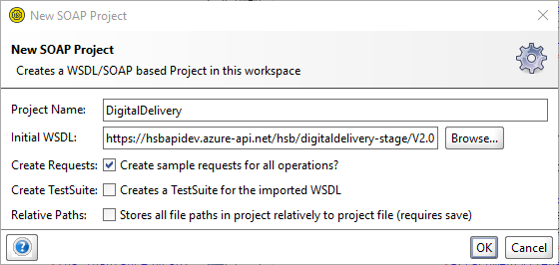

Click on request after successful project creation. Replace service url and sample request
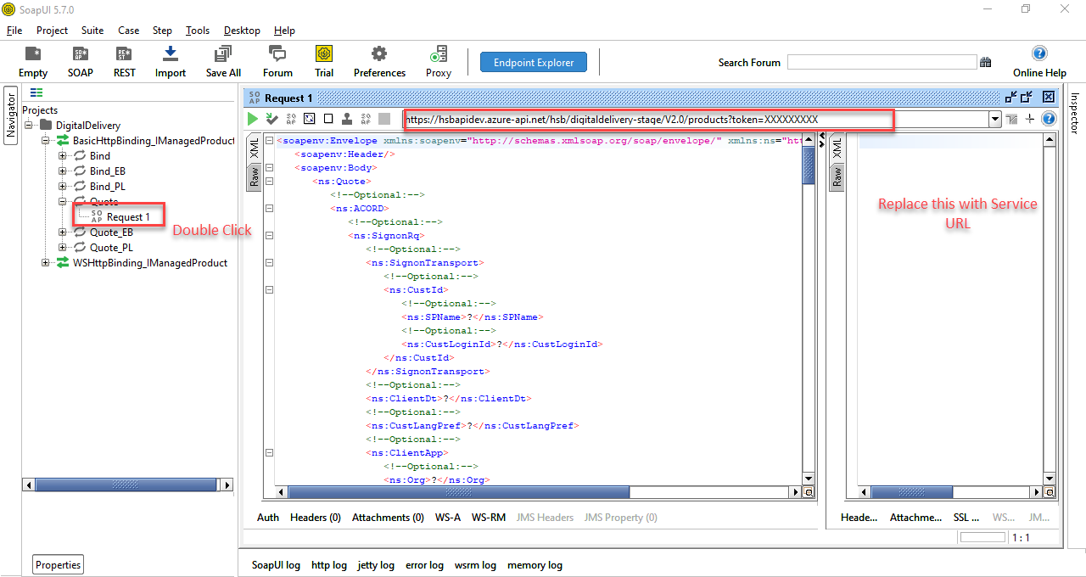

Below attachment for quote request and response.
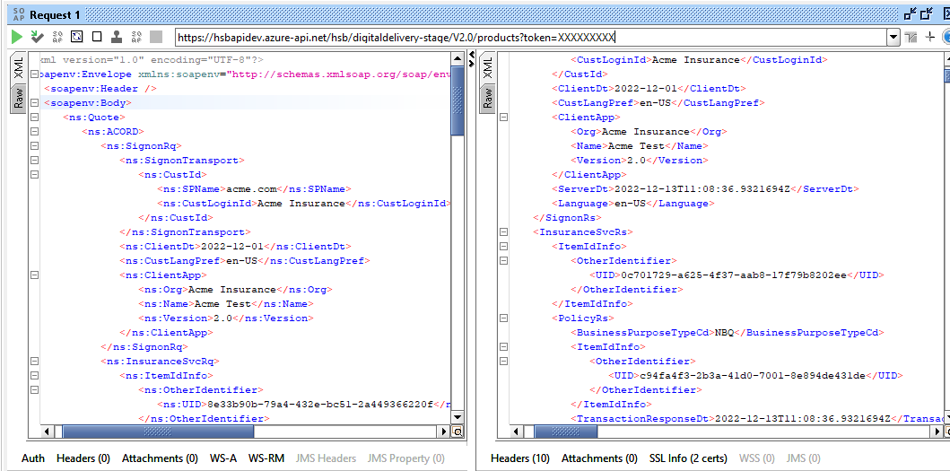

Below attachment for Bind request and response.
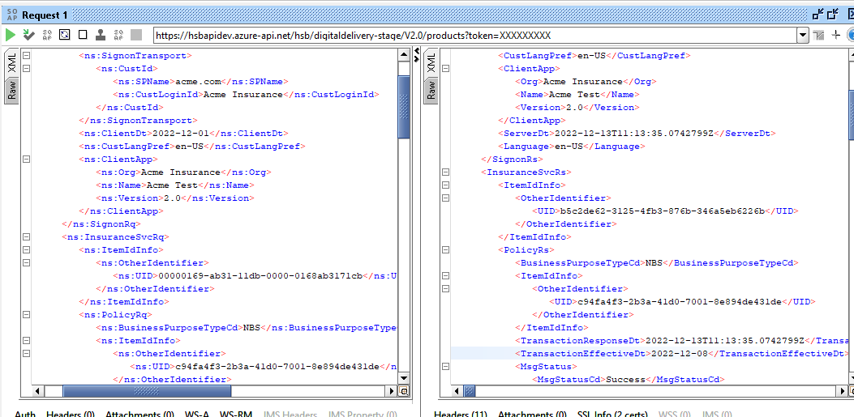

Below attachment for display FormData.
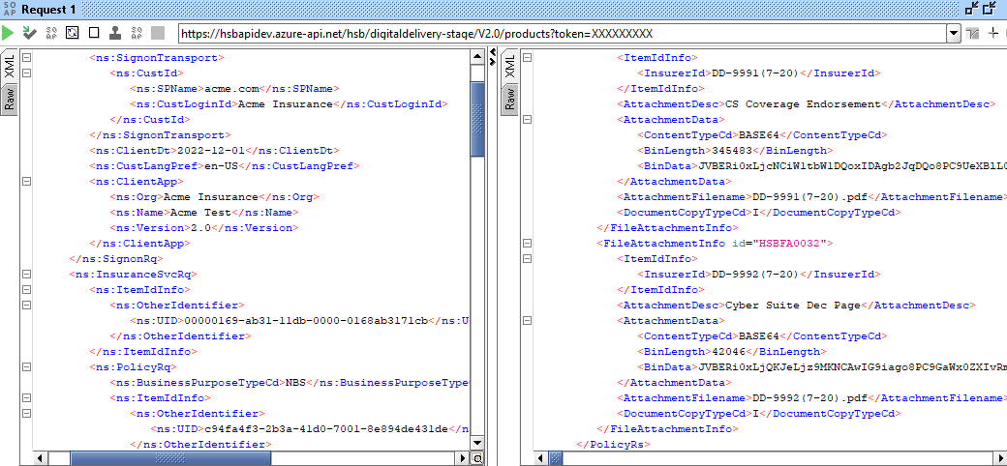

Document Revision History

Version | Date | Updated By | Revision Description
Shwetav | 4.0 |  | 06/13/2023
Shwetav | 7.0 | 05/08/2024 | Added Reinstatement transaction on the Bind API, new error code HSBERR000006 in case of invalid request.  Need to check the Transaction request date on the REI, the TransactionRequestDt cannot be greater than X days from the TransactionEffectiveDt of the matching XLC transaction. X is the number of days in which cancelled policy can be reinstated.  Example - X = 3 | XLC - Transaction effective date = 4/18/2024 | REI Transaction request date = 4/21/2024, then Error. HSBERR000006 - Cancelled Policy cannot be reinstated.
Fran Zygmont | 8.0 | 11/13/2024 | Added reporting (bordereau & inforce file) required fields for quote and bind request (sections 5.1 and 6.1). Also added column for error codes for remediation steps (section 7) along with new HSBERR000007 & HSBERR000008.

